**HSE-information for residents  
(Health, Environment, and Safety)**

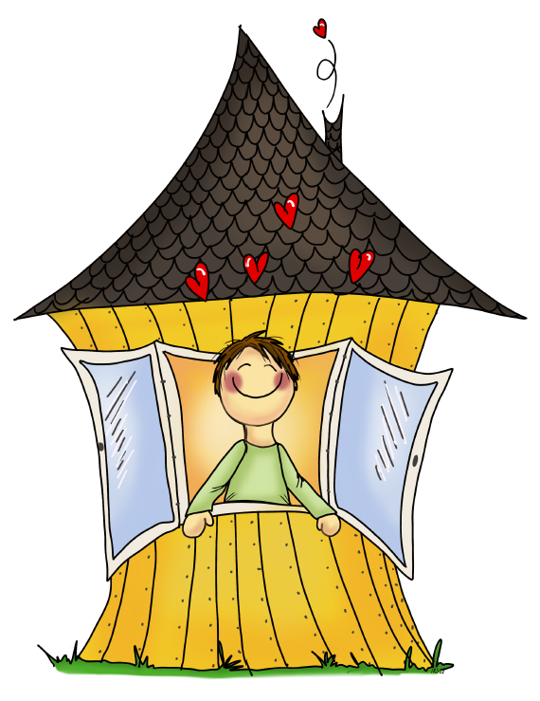The housing association wants to make a safe and comfortable environment for everyone. We all need to work together to take care of both the buildings and outdoor areas. Most important is fire safety, checking electrical equipment, and maintaining common areas and playgrounds.

There are certain rules and regulations that we, as a housing association, must follow. These include laws that protect against fires and explosions, pollution, and electrical hazards. These laws apply to both the housing association board and resident like you.

It is important that all residents take care of their own homes. This will help to prevent fires, electrical problems, water leaks, and other issues. We have made a checklist for you to review every year.

*BevarHMS is a HSE- and internal control system for housing associations, see bevarhms.no. Illustration by lykketegning.no*

|  |  |
| --- | --- |
| Resident's responsibility (own housing unit) | Housing association's responsibility |
| * Inspect and maintain electrical systems. * Following a user manual when installing or using electrical equipment. * Tell the housing association if you find any problems concerning fire safety. * Make sure that work, such as repairs and other changes, are done correctly. * Tell the board if you have seen pests in your home. * Tell the board about issues that may affect neighbours or need attention from the housing association. This includes problems with the electrical system in common areas. | * Check and perform necessary internal control (self-inspection) * Inspect and maintain common areas. * Follow up problems that have been reported. * Keep residents informed about their safety duties (HSE). |

Take time to read the fire instructions, which will give you important information on how to respond in case of a fire. Please note that the housing association does not insure any of the belongings in your home, so you must have your own home content insurance.

**Creating a safe and pleasant living environment is a shared effort!**

Kind Regards,

The Board of the housing association

**HSE-CHECKLIST**

|  |  |  |
| --- | --- | --- |
| **No.** | **Checkpoints** | **Sikkerhverdag.no** |
| **1** | **Are escape routes (windows and doors) in good condition and easy to access?**  Check escape routes and discuss how to act in case of a fire with everyone in the household, especially the children. |  |
| **2** | **Are smoke detectors in working order (tested)?**  Smoke detectors should be tested often, and every time you have been away from your home for a long time. Smoke detector should not be older than 10 years. Remember to change the battery frequently. For more information on the right location and number of smoke detectors, visit [sikkerhverdag.no](https://www.sikkerhverdag.no/brann/roykvarslere/slik-plasserer-du-roykvarsleren/). The sound from a smoke detector should be heard clearly in bedrooms with the door closed. |  |
| **3** | **Is your fire extinguishing equipment in good condition?**  House fire hose: Ensure it is connected to a tap. Unroll the entire hose and check that both the tap and nozzle are working, and that there are no cracks.  Fire extinguisher: Check that the gauge on the extinguisher has an arrow that points within the green area. Turn the extinguisher upside down periodically to prevent the powder inside from becoming hard and compressed. |  |
| **4** | **Is the fuse box in good condition – no heat, and the key is in place?**  Anything that doesn’t need to be inside a fuse box should be removed. Check that the circuits are marked clearly. Make sure that the fuses are screwed in. If a fuse blows often or becomes very hot, it should be inspected by an electrician. We recommend keeping a flashlight in the cabinet. |  |
| **5** | **Is electrical equipment such as wiring, sockets, plugs, lamps, etc., in good condition?**  If you see scorch marks, this is a serious warning sign. Don’t light bulbs that are too powerful. Heaters must not be covered or placed near flammable materials such as curtains and furniture. Fan heaters and loose lamps should never be used in children's rooms. Be careful using sockets and plugs that are not firmly connected and might be hot. Check for cracked wires. Avoid using extension cords when you can. |  |
| **6** | **Do you switch off electric devices properly after use?**  Always switch off the washing machine, dishwasher, and dryer before leaving home. Remove dryer lint after use. If the washing machine/dryer is on overnight, put a fire alarm nearby for early smoke and fire detection. Place the alarm farther from the machine to avoid setting it off with steam. Put a fire extinguisher and flashlight between the bedroom and machines. Unplug devices like kettles, coffee makers, and curling irons if they don't have a safety timer, and do not pull the cord. |  |
| **7** | **Have you considered getting a stove guard?**  Boiling pots dry is a common reason for fires. If you often forget to turn off the oven, there are devices that can automatically turn off the power after a set time. If you are elderly or disabled check with the aid center (hjelpemiddelsentralen) for help. Since 2010 stove guards have been required in new homes, and when installing a new oven in older buildings. |  |
| **8** | **Is there a risk of water leakage?**  Change water hoses and drain lines for dishwashers that are older than 10 years. Check for leaks behind and under the dishwasher, washing machine, water heater, and kitchen and bathroom sinks (u-bend). Make sure that drains from the washing machine and dishwasher are attached tightly. Clean floor drains at least 1-2 times a year, depending on how often they are used. Clean the drain on your terrace or balcony when needed. Make sure you know where the stop valve for your home is located. |  |
| **9** | **Ventilation**  Are air vents in the wall, above the window, or from the ventilation system open? This lets fresh air in and removes moisture from the air. It is important to clean the extractor fan above the stove, because grease in the filter can cause a fire if overheated. If your home has its own heat pump, make sure to vacuum the dust filters inside. If your home has a ventilation system, remember to change the filter and follow the manual. |  |